**Build an Employee Travel Approval Application for Corporates**

Created by using



**Sales*f*orce Platform**

Project done by

**Sk Lohinaz**

**J Kusuma Indhu**

**Ch Satya Valli**

**R Naga Venkata AdiLakshmi**

As a part of

**Salesforce Certified virtual internship**

Certification course Provided by

**SmartIntrenz**

|  |  |  |
| --- | --- | --- |
| **TABLE OF CONTENTS** | | |
| **S.No** | **Content** | **Page No** |
| 1 | Introduction | 3 |
| 2 | Creating a developer org | 3 |
| 3 | Creating Objects | 3 |
| 4 | Fields and relationships for Custom Objects | 6 |
| 5 | Custom tabs | 9 |
| 6 | Lightning app | 10 |
| 7 | Data Import Wizard | 11 |
| 8 | Creating User | 12 |
| 9 | Travel Approval Page layout Customization | 14 |
| 10 | Create Validation Rules for Travel Approval | 15 |
| 11 | Formulae Fields | 16 |
| 12 | Reports | 17 |
| 13 | Travel Approval Dashboard | 19 |

**Introduction**

The project at hand involves the development of an Employee Travel Approval Application specifically designed for corporate environments, utilizing the robust Salesforce platform. This application aims to streamline and automate the process of managing travel requests, ensuring a seamless experience for employees, managers, and travel administrators.

The Employee Travel Approval Application will leverage the extensive capabilities of Salesforce to provide a comprehensive solution for managing travel requests, approvals, and related processes. It will offer a user-friendly interface that enables employees to submit travel requests easily and efficiently, while providing managers with a clear overview of the requests and the ability to review and approve them promptly.

**Creating a developer org**

To kickstart this project, I took the initiative of setting up a Salesforce Developer Edition, a specialized environment tailored for developers, to serve as the foundation for my work.

**Creating Objects**

After successfully setting up the developer org, I proceeded to create a set of custom objects that would meet the specific requirements of our project. These custom objects were carefully designed and tailored to accommodate the unique data and processes relevant to our project's objectives. While creating the custom objects, an important requirement was to ensure that they were equipped with the ability to generate reports and enable efficient search functionality. As such, special attention was given to configuring these custom objects to seamlessly support reporting and facilitate easy searching across the data stored within them. This ensures that users can effectively analyze and retrieve the desired information from the custom objects, enhancing the overall usability and value of our project. The Departments created are following.

1. Department

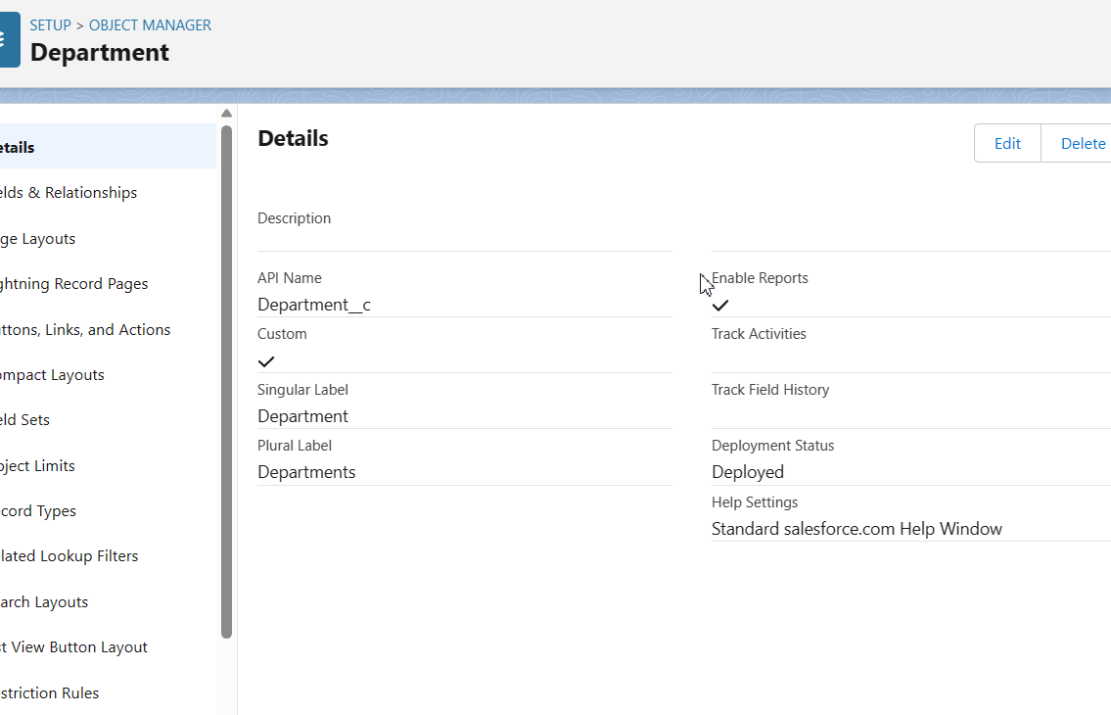

1. Employee Detail

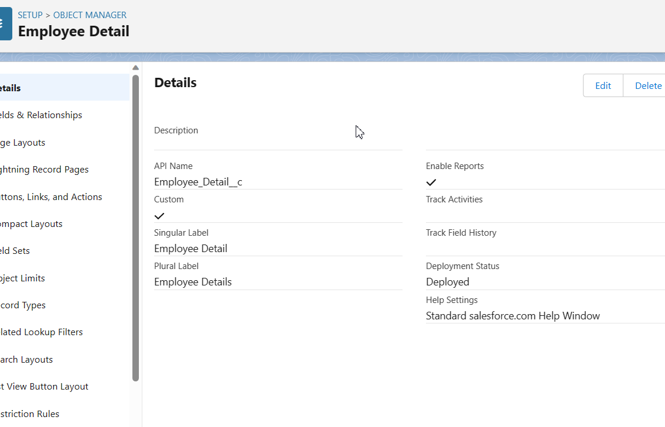

1. Expense

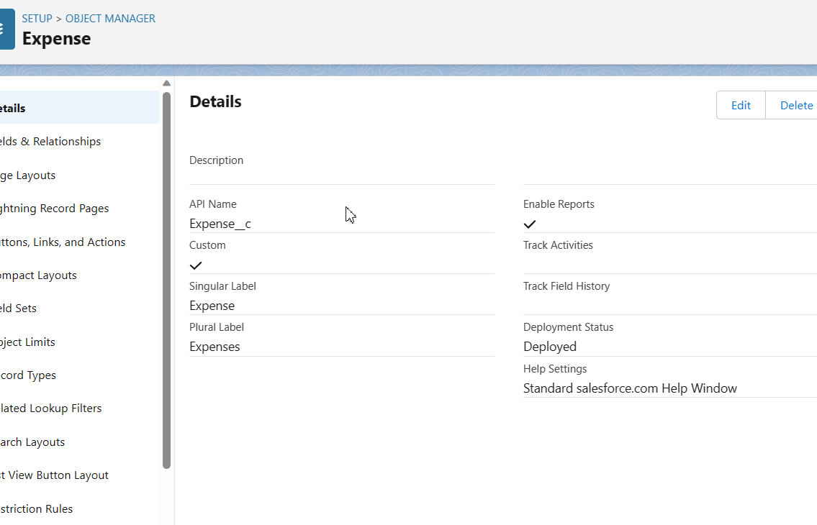

1. Expense Item

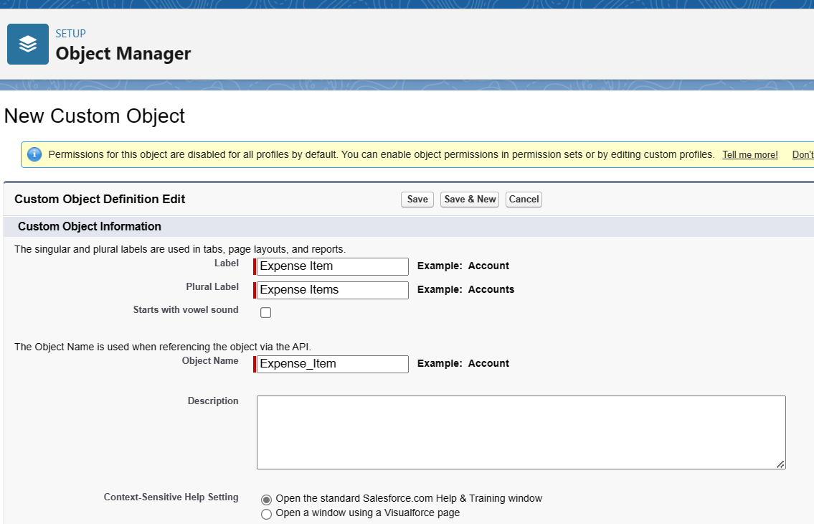

1. Travel Approval

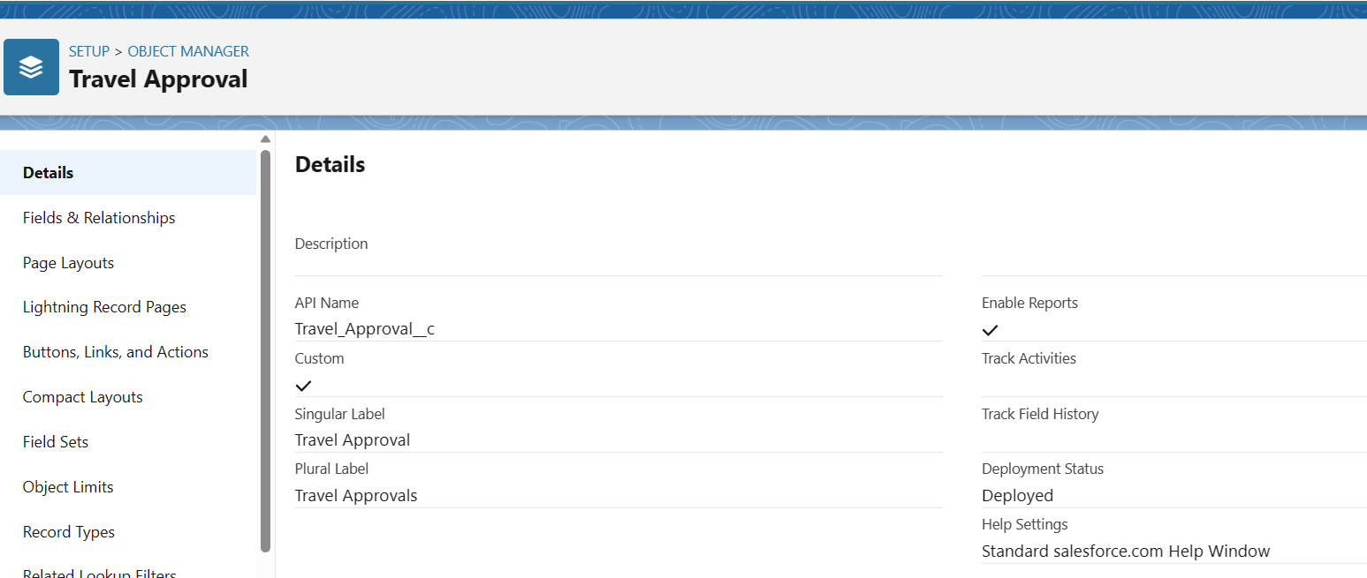

**Fields and relationships for Custom Objects**

Fields:

Fields are individual data elements that represent specific attributes or properties of an object. They define the types of data that can be stored and manipulated within a database or application. Each field typically has a name and a data type associated with it. Examples of common field types include text, number, date, picklist (dropdown), checkbox, and email.

For example, in a User object, fields such as First Name, Last Name, Email, and Role would represent different attributes of a user and would each have their own corresponding field in the database.

Relationships:

Relationships define the connections or associations between different objects or entities in a database. They establish how data in one object is related to data in another object. Relationships are used to link and navigate between different records, enabling the retrieval and manipulation of related data.

As part of this project, I have established a set of fields and relationships to effectively structure and organize the data. These fields represent specific attributes or properties of the objects involved, while the relationships define the connections and associations between the objects. The chosen fields and relationships are tailored to meet the project's requirements and ensure efficient data management.

Below are the fields and relationships created for this project for

1. Department Object

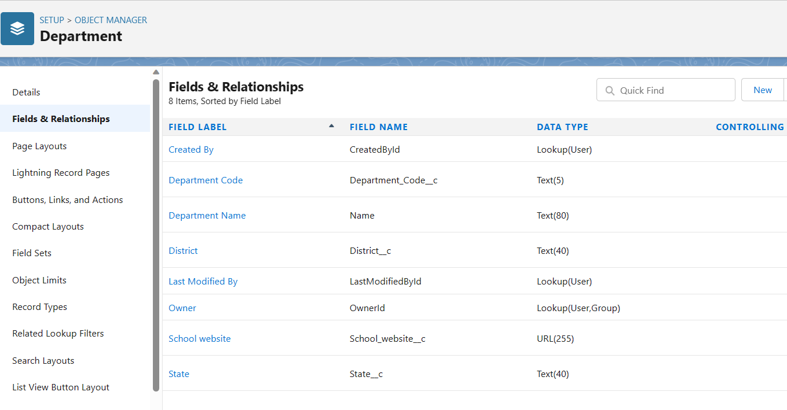

1. Employee Detail Object

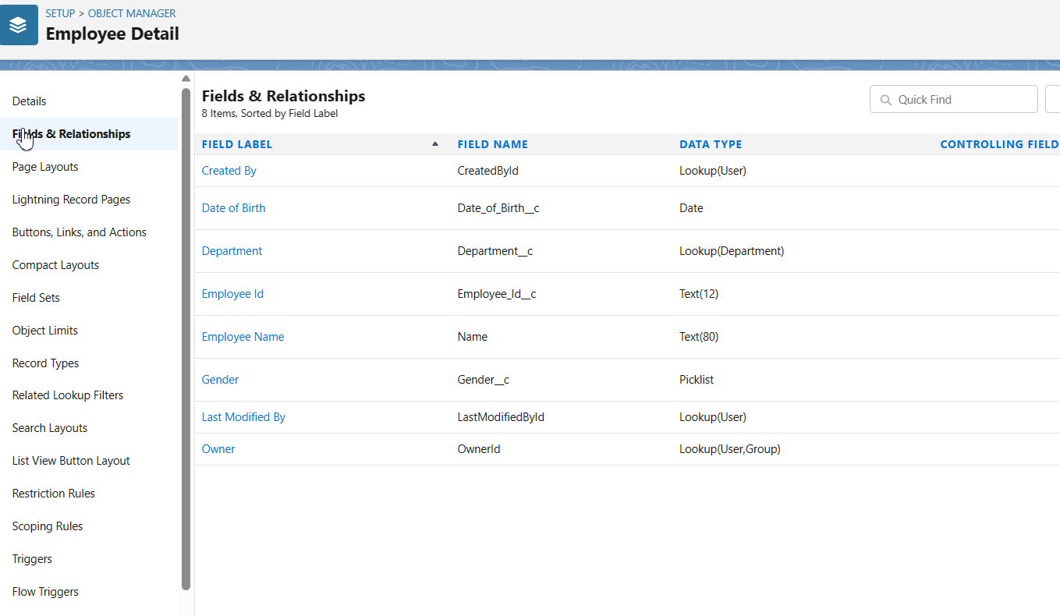

1. Expense Object

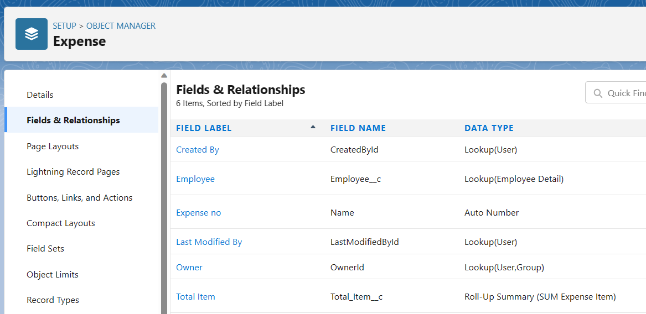

1. Expense Item Object

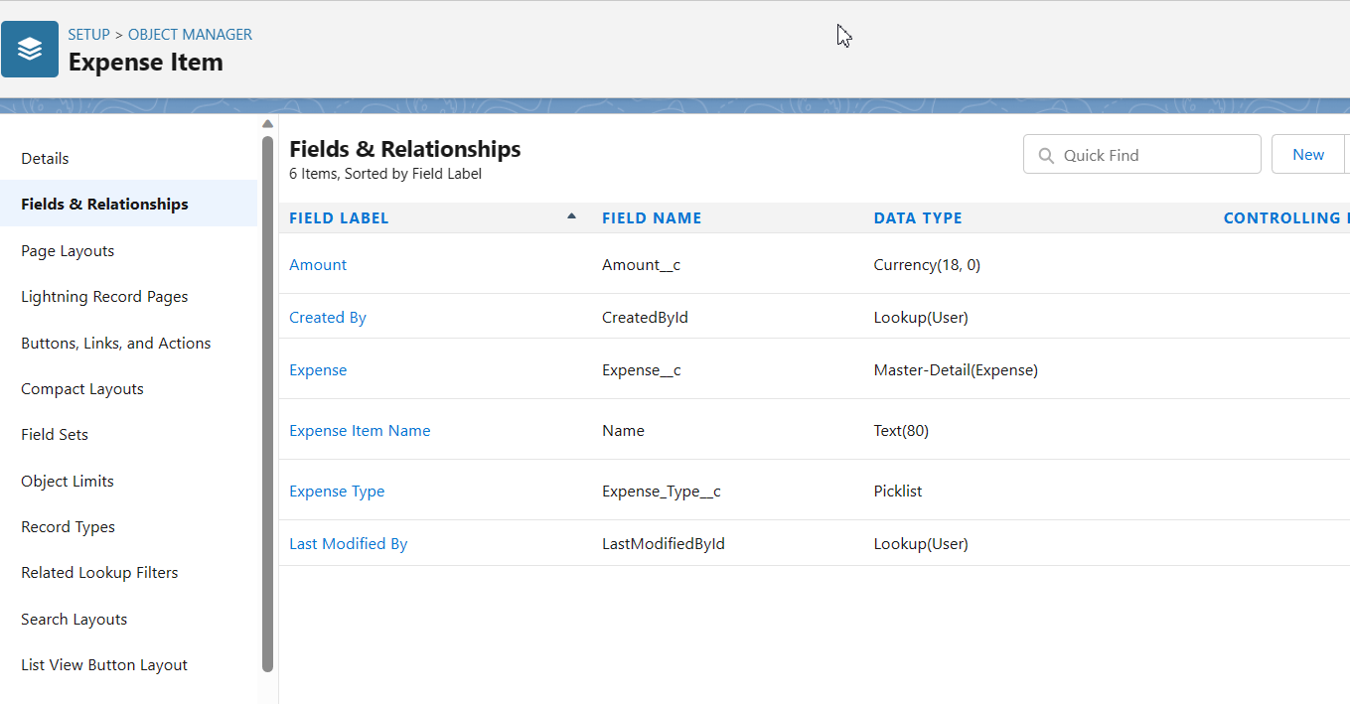

1. Travel Approval Object

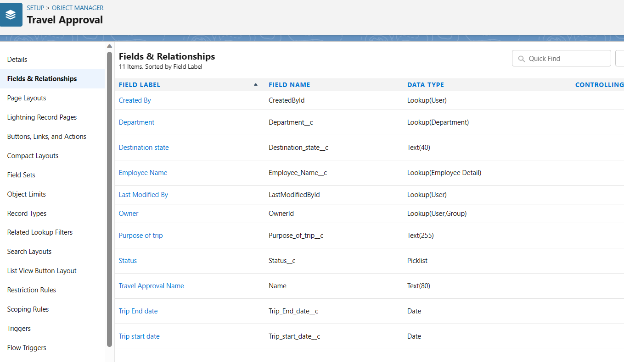

**Custom tabs**

Custom object tabs play a vital role in streamlining and enhancing the user experience within the Salesforce application. These tabs serve as dedicated entry points that grant users access to custom objects, enabling them to efficiently manage and interact with the associated records. The primary purpose of custom object tabs is to provide a seamless and intuitive interface for users to perform a range of operations on custom objects. Whether it's viewing existing records, creating new ones, editing details, or managing related records, custom object tabs offer a centralized and focused space for users to perform these tasks within the Salesforce environment. By creating custom object tabs, organizations can tailor the Salesforce platform to their unique business requirements. These tabs are specifically designed to accommodate custom objects that are built to capture and organize data that is crucial to the organization's processes and workflows. Whether it's tracking customer interactions, managing project milestones, or recording inventory details, custom object tabs ensure that the specific needs of the business are met efficiently and effectively. The functionality of custom object tabs extends beyond basic record management. Administrators and developers have the flexibility to customize various aspects of these tabs to align them with the desired user experience. This customization includes defining the tab's label, name, and icon, as well as configuring visibility settings based on user profiles or roles. Additionally, related lists and default list views can be customized within the tabs, providing quick access to related records and allowing users to navigate through related data seamlessly. Integration is another notable advantage of custom object tabs. These tabs seamlessly integrate with other features and functionalities within Salesforce, ensuring a cohesive user experience. They can be seamlessly incorporated into Salesforce apps, page layouts, and custom applications, providing consistent navigation and accessibility across different areas of the platform. This integration eliminates the need for users to switch between various applications, increasing productivity and efficiency. Moreover, custom object tabs offer granular control over user access and permissions. Administrators can configure tab visibility based on user profiles or permission sets, ensuring that only authorized users have access to specific custom object data. This helps maintain data security and privacy within the organization while allowing for streamlined collaboration and data management.

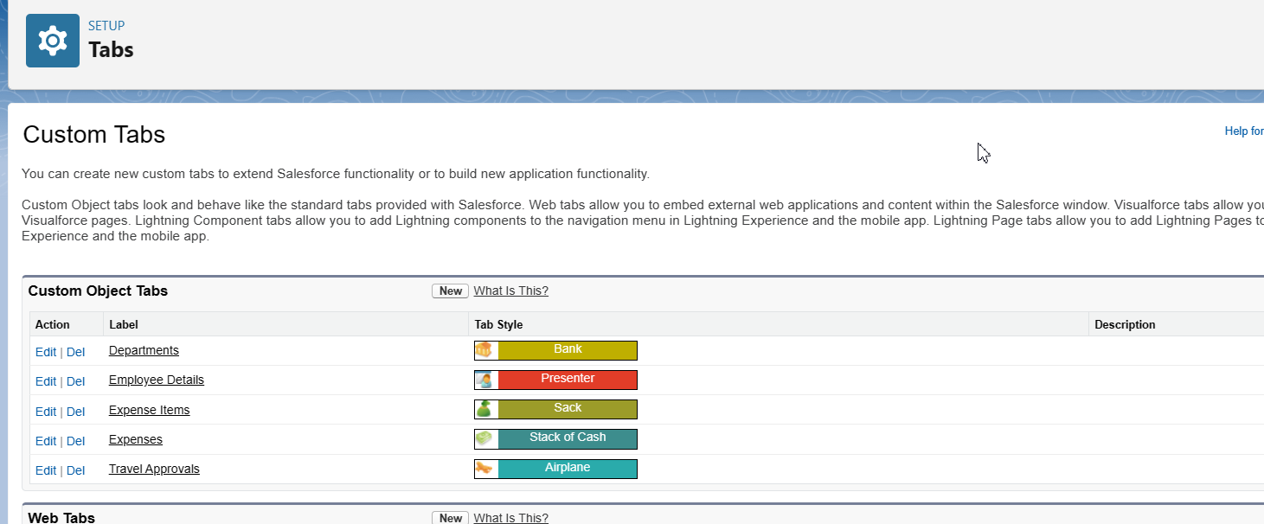

As part of my project, I have created custom tabs to enhance the user interface and provide convenient access to specific objects within the Salesforce application. These custom tabs serve as entry points for users to interact with and manage data associated with custom objects that have been tailored to meet specific business needs. Here are some details about the custom tabs that I have created for objects:

**Lightning app**

Lightning apps are an integral part of the Salesforce ecosystem, providing a modern and responsive user interface that enhances productivity and usability. Leveraging the Salesforce Lightning Platform, these apps are designed to optimize the user experience by delivering a customizable, visually appealing, and performance-driven interface. Lightning apps support collaboration and real-time updates, enabling users to collaborate on records, track changes, and receive instant notifications. This fosters efficient teamwork and ensures that users stay informed about relevant updates and changes.

Lightning apps are designed to be mobile-friendly, providing a responsive and optimized user experience on mobile devices. Users can access and interact with their Lightning apps on-the-go, enabling them to stay productive and connected while away from their desktops.

Salesforce also offers a range of Lightning app templates and solutions through the AppExchange marketplace. These pre-built apps provide ready-to-use functionality for specific industries or business processes, allowing organizations to quickly deploy robust solutions without extensive development efforts.

Moreover, Lightning apps are compatible with Lightning Communities, which are online spaces where organizations can engage with customers, partners, and employees. Lightning apps can be embedded within Lightning Communities to provide a consistent user experience and extend functionality to external users.

With the Lightning App Builder and Lightning Component Framework, developers have the flexibility to create custom components and extend the capabilities of Lightning apps. This empowers organizations to build tailored solutions that meet their unique requirements and integrate seamlessly with their existing Salesforce environment.

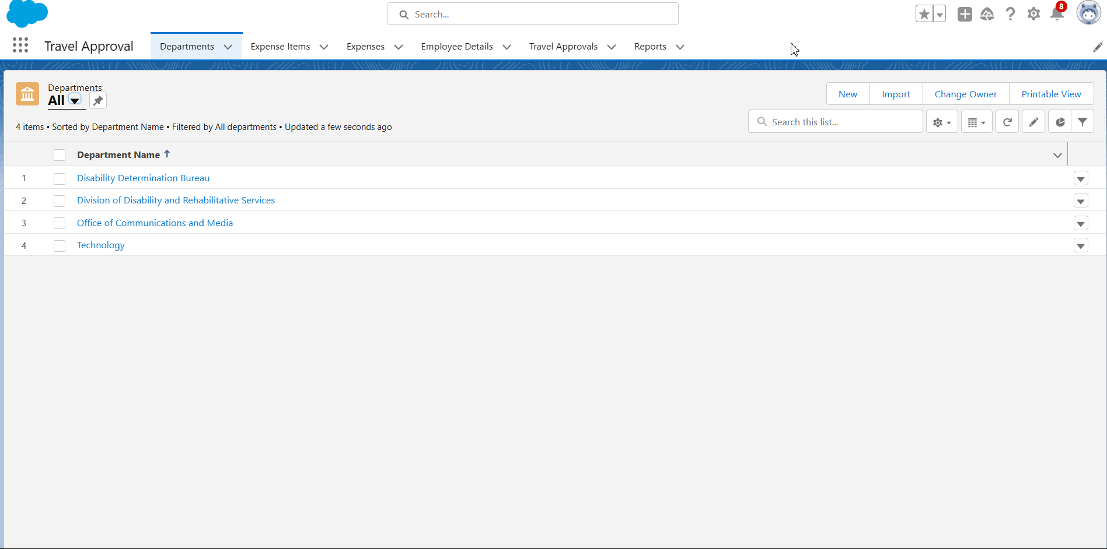

**Data Import Wizard**

The Data Import Wizard is a tool provided by Salesforce, a cloud-based customer relationship management (CRM) platform. It allows users to easily import data from external sources into their Salesforce org (organization). With the Data Import Wizard, you can import various types of data, including accounts, contacts, leads, solutions, custom objects, and more. The wizard provides a step-by-step process to guide you through the data import process, making it accessible to users with varying levels of technical expertise. Here are the key steps involved in using the Data Import Wizard:

1. Prepare your data: Organize your data in a compatible format such as CSV (comma-separated values) or Excel files. Ensure that your data follows Salesforce's data requirements and guidelines.
2. Access the Data Import Wizard: Log in to your Salesforce org and navigate to the Setup menu. Search for "Data Import Wizard" in the Quick Find box or find it under the Data Management section.
3. Select the data objects: Choose the specific Salesforce object (e.g., accounts, contacts) to which you want to import your data.
4. Map your fields: Map the fields from your source file to the corresponding fields in Salesforce. This step ensures that the data is correctly aligned during the import process.
5. Import options: Specify import options such as how to handle duplicate records, whether to trigger workflow rules or validations, and other relevant settings.
6. Validate and import: Validate your data to identify any potential issues or errors. Once validated, you can proceed with the actual data import process.
7. Monitor and review: After the import starts, you can monitor its progress and review any error messages or notifications. Salesforce provides detailed logs to help you troubleshoot and resolve any problems.

It's important to note that the Data Import Wizard has certain limitations, such as a maximum file size and limitations on the number of records you can import at once. If you need to import larger volumes of data or have more complex requirements, you may need to explore alternative data loading methods, such as using Salesforce Data Loader or working with specialized integration tools.

Remember to review the Salesforce documentation and consult with your system administrator or Salesforce support for specific guidance on using the Data Import Wizard within your Salesforce org.

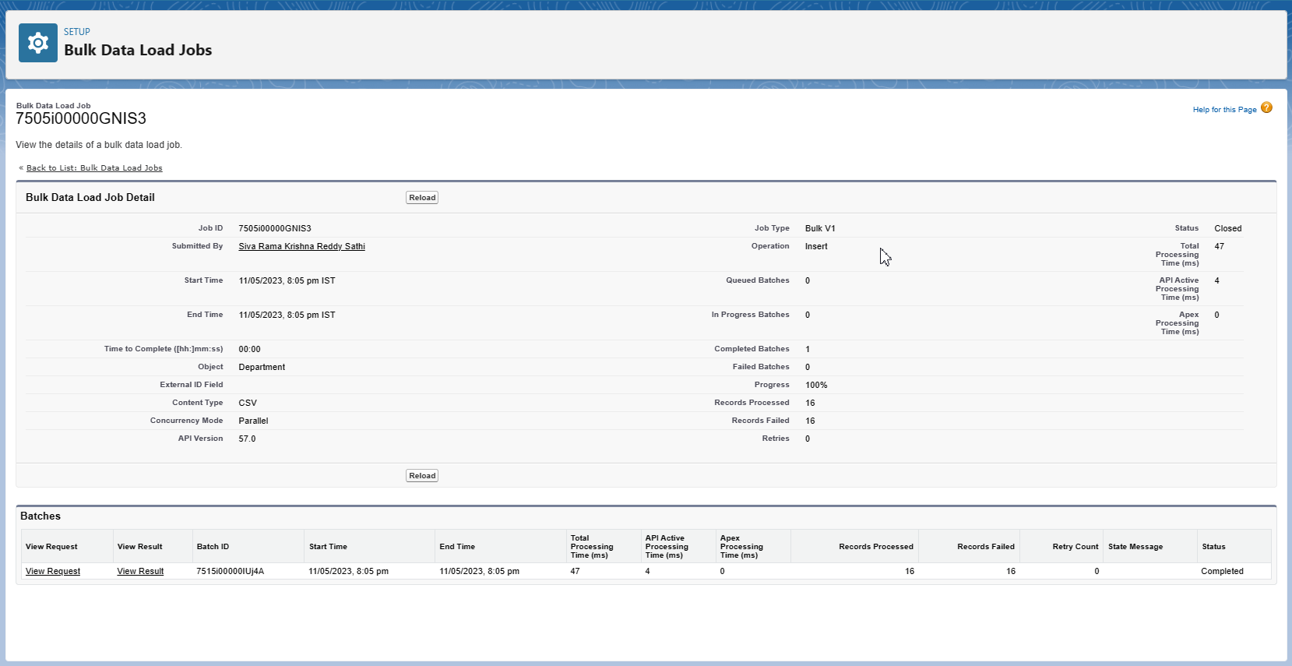

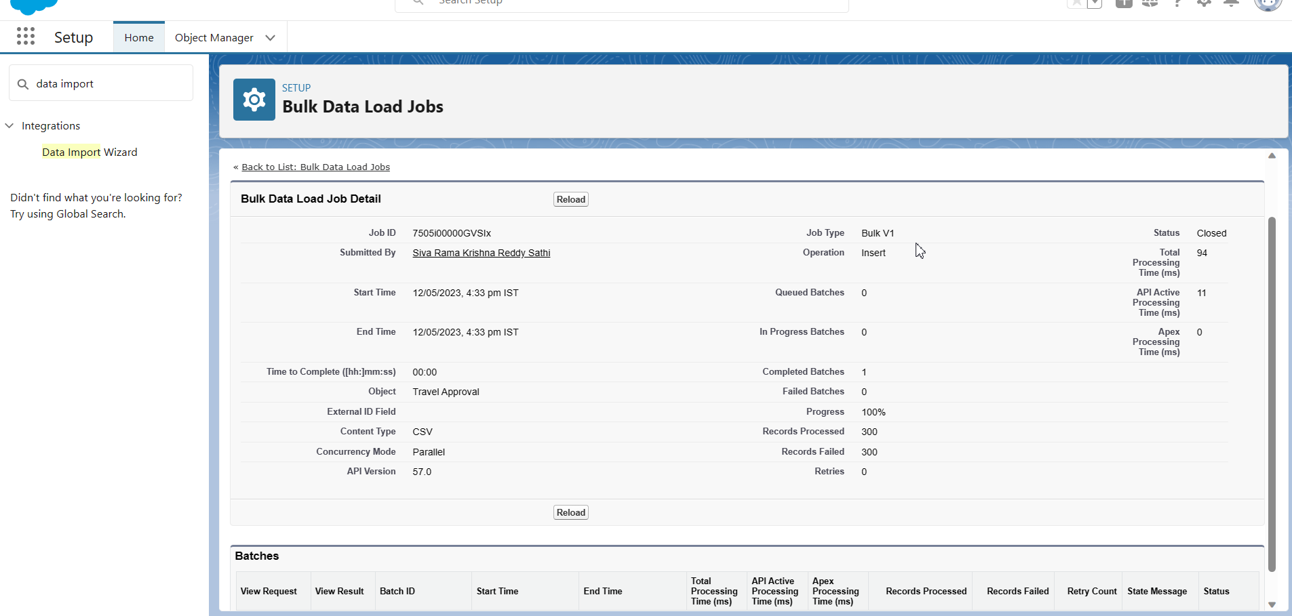

**Creating User**

To create a user in Salesforce, you need to have the necessary administrative privileges. As a system administrator or a user with the "Manage Users" permission, you can follow these steps to create a new user:

1. Log in to your Salesforce org with your administrative credentials.
2. Click on the user avatar or your profile picture in the top-right corner, and select "Setup" from the dropdown menu.
3. In the Salesforce Setup page, navigate to the "Users" section. You can use the Quick Find search box and type "Users" to quickly locate it.
4. Click on "Users" to access the User Management page.
5. On the User Management page, click the "New User" button to start creating a new user.
6. Fill in the required details for the new user, such as their first name, last name, and email address. These fields are marked with asterisks (*) to indicate they are mandatory.
7. Assign a unique username for the user. This username is used for login purposes and must be unique across the Salesforce org.
8. Choose a user license from the available options. User licenses determine the set of features and functionalities the user will have access to.
9. Select a profile for the user. Profiles define the object and data-level permissions that the user will have. Choose a profile that aligns with the user's role and responsibilities.
10. Specify the user's time zone, locale, and other relevant details as needed.
11. Set a temporary password for the user. Optionally, you can choose to generate an email with login instructions and the temporary password to be sent to the user.
12. Review the user details and ensure they are accurate.
13. Click the "Save" button to create the user.

Once the user is created, they will receive an email with instructions on how to log in to Salesforce using their username and temporary password. As an administrator, you can later modify the user's permissions, roles, and other settings as necessary. It's important to note that the specific steps and options may vary slightly depending on the version and edition of Salesforce you are using.

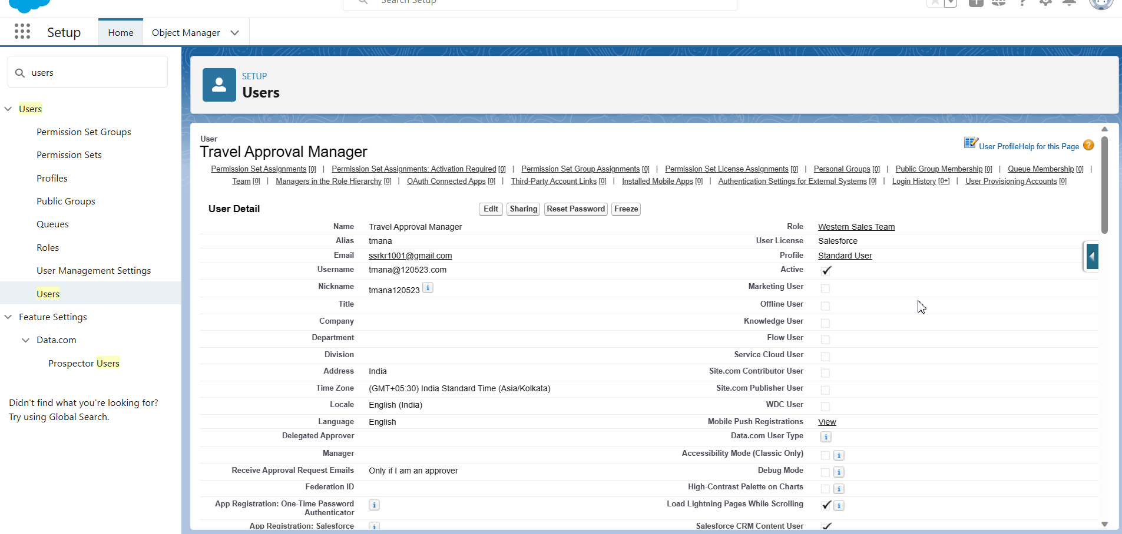

**Travel Approval Page layout Customization**

To customize the Travel Approval page layout in Salesforce, follow these steps:

1. Log in to your Salesforce org with your administrative credentials.
2. Click on the user avatar or your profile picture in the top-right corner, and select "Setup" from the dropdown menu.
3. In the Salesforce Setup page, navigate to the "Object Manager" tab.
4. In the Object Manager, search for the object related to the Travel Approval page layout. The object name may vary based on your organization's customization.
5. Once you find the appropriate object, click on it to access the Object Manager for that object.
6. In the Object Manager, click on "Page Layouts" in the left-hand sidebar.
7. On the Page Layouts page, locate the Travel Approval page layout and click on it to edit.
8. The page layout editor will open, displaying the current layout of the Travel Approval page.
9. To add fields to the layout, click on the "Fields" tab in the palette on the left side of the editor.
10. Drag and drop the desired fields from the palette onto the layout.
11. To remove fields from the layout, hover over the field on the layout and click on the delete (X) icon.
12. You can rearrange the fields on the layout by dragging and dropping them to the desired positions.
13. Customize the properties of the fields by clicking on the wrench icon that appears when you hover over a field on the layout.
14. To add related lists or related record components to the layout, click on the "Related Lists" or "Related Record" tabs in the palette and drag them onto the layout.
15. Customize the layout sections, columns, and properties using the tools available in the layout editor.
16. Save your changes once you are satisfied with the layout modifications.

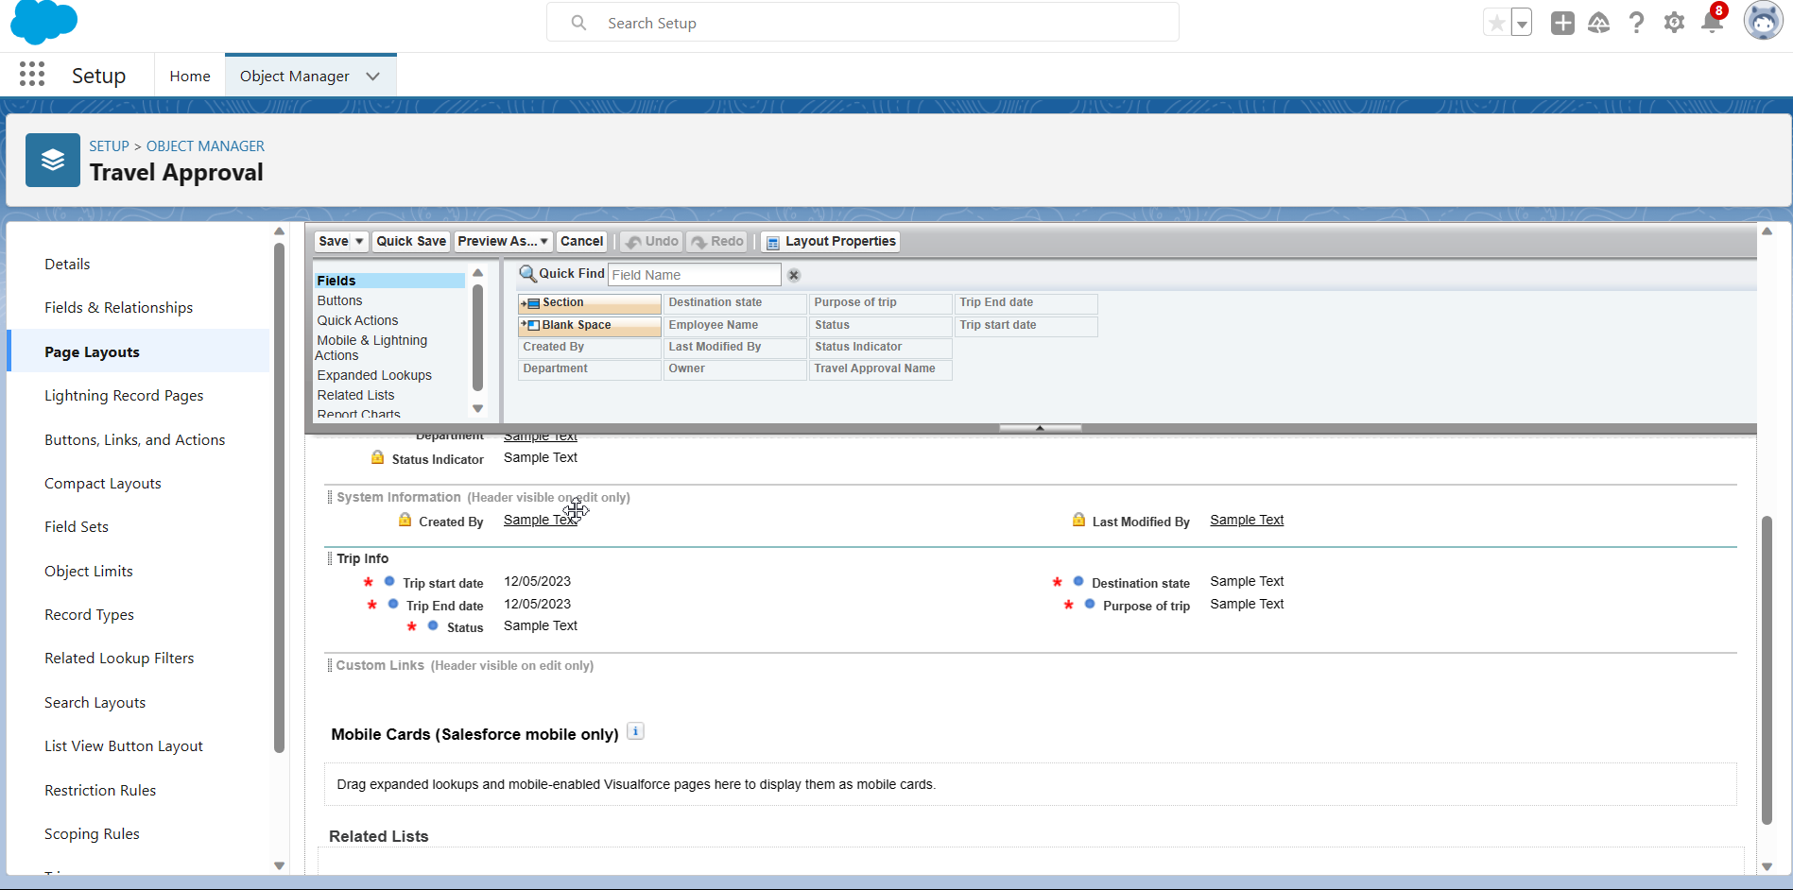

Remember to consider the user experience and usability when customizing the page layout. Ensure that the most important and relevant fields and components are easily accessible to users.Additionally, consider the impact on mobile devices if your Salesforce org is used on mobile platforms. Please note that the specific steps and options for customizing page layouts may vary depending on the version and edition of Salesforce you are using, as well as any customizations made by your organization.

**Create Validation Rules for Travel Approval**

To create a validation rule in Salesforce that checks if the Trip End Date is before the Trip Start Date on the Travel Approval object, you can follow these steps:

1. Log in to your Salesforce org with your administrative credentials.
2. Click on the user avatar or your profile picture in the top-right corner, and select "Setup" from the dropdown menu.
3. In the Salesforce Setup page, navigate to the "Object Manager" tab.
4. In the Object Manager, search for the object related to the Travel Approval.
5. The object name may vary based on your organization's customization.
6. Once you find the appropriate object, click on it to access the Object Manager for that object. In the Object Manager, click on "Validation Rules" in the left-hand sidebar.
7. On the Validation Rules page, click the "New Validation Rule" button.
8. Enter a name for the validation rule, such as "Trip Date Validation."
9. Provide a description to explain the purpose of the validation rule, if desired.
10. In the "Error Condition Formula" section, enter the following formula: **Trip_End_Date__c < Trip_Start_Date__c** This formula checks if the Trip End Date is before the Trip Start Date.
11. Optionally, you can enter an error message that will be displayed when the validation rule is triggered.
12. Choose the appropriate error location, such as "Field" or "Inline," based on where you want the error message to be displayed.
13. Click the "Save" button to create the validation rule.

Once the validation rule is created, whenever a user tries to save a Travel Approval record with the Trip End Date before the Trip Start Date, the validation rule will be triggered, and the specified error message will be displayed. Please note that the field names "Trip_End_Date__c" and "Trip_Start_Date__c" are placeholders and should be replaced with the actual API names of the fields on your Travel Approval object. Additionally, consider any other criteria or conditions that should be included in the validation rule to ensure it meets your specific requirements.

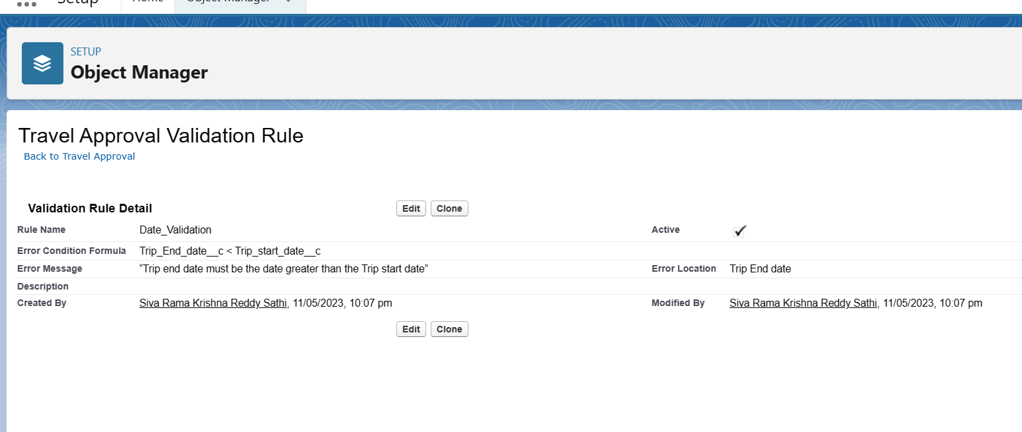

**Formulae Fields**

To create a formula field on the Travel Approval object in Salesforce, you can follow these steps:

1. Log in to your Salesforce org with your administrative credentials.
2. Click on the user avatar or your profile picture in the top-right corner, and select "Setup" from the dropdown menu.
3. In the Salesforce Setup page, navigate to the "Object Manager" tab.
4. In the Object Manager, search for the object related to the Travel Approval. The object name may vary based on your organization's customization.
5. Once you find the appropriate object, click on it to access the Object Manager for that object.
6. In the Object Manager, click on "Fields & Relationships" in the left-hand sidebar.
7. On the Fields & Relationships page, click the "New" button to create a new field.
8. Select the data type for the formula field based on the desired output. For example, if you want the formula field to display a text value, select "Text" as the data type.
9. Click the "Next" button to proceed.
10. Provide a field label for the formula field. This is the name that will be displayed on the record detail page.
11. Enter a unique field name for the API name of the formula field. The API name is used for integrations and automation processes.
12. In the "Formula" section, enter the formula that calculates the value for the field. You can use Salesforce's formula language to combine fields, perform calculations, and apply logic. For example, if you want to concatenate the values of the Trip Start Date and Trip End Date fields, the formula could be: TEXT

**IF(ISPICKVAL(Status__c, 'Approved') , IMAGE("/resource/StatusImages/thumbs-up.png", "Accepted", 20, 20),**

**IF (ISPICKVAL (Status__c, 'Rejected'), IMAGE ("/resource/StatusImages/thumbs-down.png", "Rejected", 20, 20),**

**IMAGE ("/resource/StatusImages/draft.png", "In-Process", 20, 20)))**

1. Optionally, you can provide a description for the formula field to document its purpose and usage.
2. Set the appropriate field-level security and visibility settings based on your requirements.
3. Click the "Next" button to proceed.
4. Review the field details and ensure they are accurate.
5. Click the "Save" button to create the formula field.

Once the formula field is created, it will be available on the Travel Approval object, and its value will be dynamically calculated based on the specified formula. The formula field can be included on page layouts, reports, and other Salesforce components where fields are displayed. Please note that the specific formula syntax and functions may vary depending on your organization's Salesforce edition and customization. You can refer to the Salesforce documentation for more information on available functions and examples of formula field formulas.

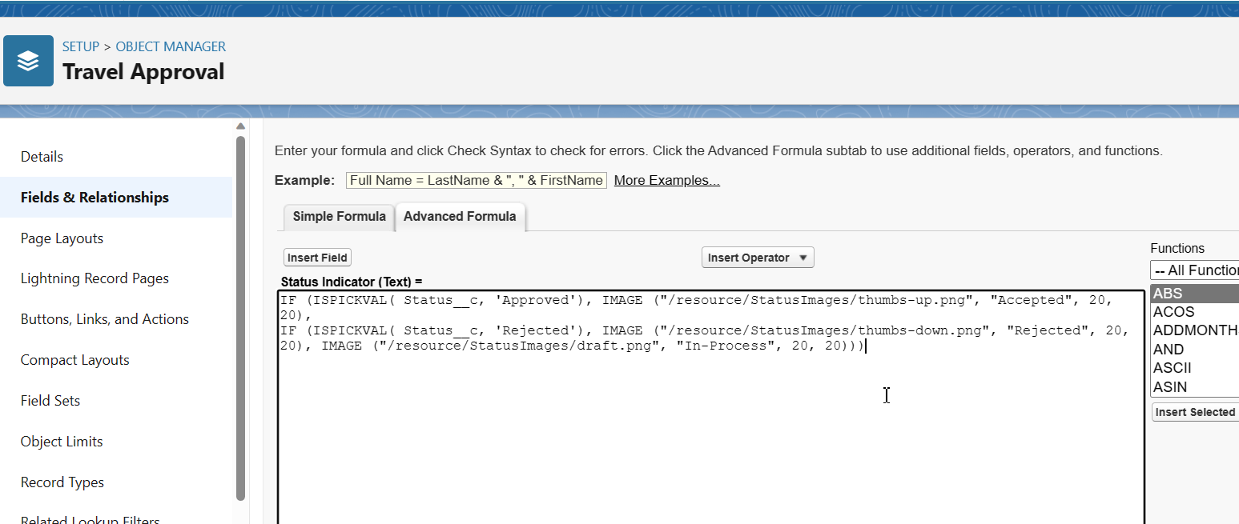

**Reports**

Reports in Salesforce are powerful tools that allow users to analyze and visualize data stored in the Salesforce platform. With reports, you can gather insights, track performance, and make informed business decisions. Here are the key aspects of working with reports in Salesforce:

* **Creating a Report:**
* Start by logging in to your Salesforce org. Click on the "App Launcher" in the top-left corner and search for "Reports."
* Click on "Reports" to access the Reports tab. Click the "New Report" button to create a new report.
* Select the desired report type that corresponds to the object or data you want to report on (e.g., Accounts, Opportunities, Cases).
* Configure the report criteria and filters to define the data set you want to include.
* Choose the fields you want to display in the report.
* Customize report grouping, sorting, and summarization options as needed. Click "Run Report" to generate the report and view the data.
* **Report Formats:**
* Salesforce offers various report formats to present data, including tabular reports, summary reports, matrix reports, and joined reports.
* Tabular reports display data in rows and columns, similar to a spreadsheet.
* Summary reports provide a summary of data grouped by specific criteria, with subtotals and grand totals.
* Matrix reports present data in a grid format, allowing for cross-tabulation and grouping by rows and columns.
* Joined reports combine data from multiple report types into a single report.
* **Customizing Reports:**
* You can customize reports by adding or removing fields, adjusting column widths, rearranging columns, and applying filters.
* Reports can be sorted by specific columns or grouped by criteria such as date, region, or owner.
* You can also add charts, graphs, and visualizations to reports to provide a visual representation of the data.
* **Saving and Sharing Reports:**
* Once you have created a report, you can save it for future use and access it from the Reports tab.
* Saved reports can be shared with other users or groups in your organization, allowing for collaboration and data-driven decision-making.
* Reports can be scheduled to run automatically and emailed to designated recipients on a regular basis.

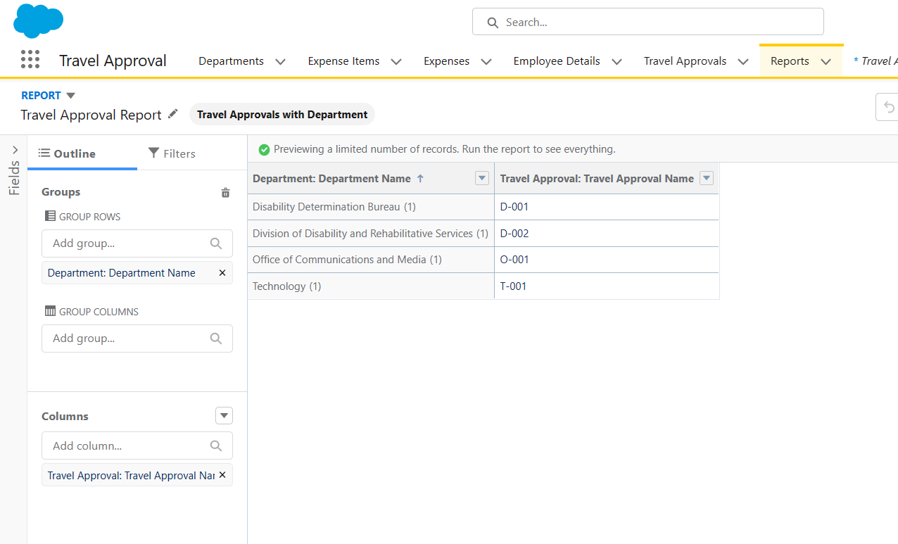

* **Report Export and Printing:**
* Salesforce reports can be exported to various formats, such as Excel, CSV, PDF, or Word, for further analysis or sharing.
* Reports can also be printed directly from the Salesforce interface.

Reports in Salesforce provide valuable insights into your data, allowing you to monitor performance, identify trends, and drive business outcomes. By leveraging the customization options and various report types available, you can create meaningful and actionable reports tailored to your specific needs.

**Travel Approval Dashboard**

This is the final outcome of the dashboard named Travel Approval

